Lab 04 - Network Firewalls
Table of Contents
Introduction 1
Initial Network Diagram (Pre-Firewall) 1
Configuring PfSense 2
Migrating Machines 4
Migrate the Desktop 5
Pfsense Gateway Setting 5
MAC Address Reservations 6
Setting Firewall Policies 7
Creating Virtual IPs and Forwarding Rules 9
Disable monitoring on the WAN interface 11
SSH on Desktop 12
Network Diagram 16

Introduction
Firewalls are a critical part of network security. There are two primary types of firewalls discussed in this class: Network Firewalls and Host-Based Firewalls. In this lab, you will work to migrate your desktop machine (X.X.X.201) behind a network firewall onto its own private network (192.168.1.0/24). A firewall provides increased control and security over the incoming and outgoing connections concerning your network.

Initial Network Diagram (Pre-Firewall)
Before you configure a network firewall, it’s important to know the layout of your network.

Your current network has the layout as seen in the image below. You have two machines using public IP addresses. We are going to change this so that most of the machines you build this semester will be behind a network firewall called pfSense. You will be using virtual IPs and routing your traffic through your firewall. Later in the semester, you will be limiting access to each machine using a host-based firewall private network. Please do not try to do this now. It will cause you problems.

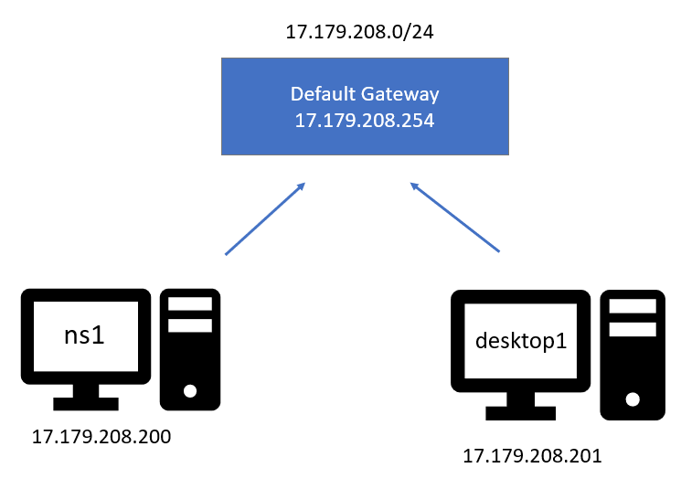

Configuring PfSense
The network firewall application we will be using is pfSense, a firewall based on FreeBSD that is commonly used throughout the industry (and the Cyber Defense Competitions). You will need pfSense to continue running for all labs moving forward. Do not power off this server. Or if you want to shut it down, remember to power it on before you try to work on your lab.

- We will start by connecting pfSense to the correct networks.
  - Ensure your pfSense box is powered off.
  - Right-click on pfSense in vSphere and choose "Edit Settings…"
  - Add a new Network Adapter by clicking “Add New Device” on the top right
  - For Network Adapter 1, choose the correct "cpre230_myoussef_blueX" by referring to the network information spreadsheet. This is the external WAN network.
  - For Network Adapter 2, choose "cpre230_myoussef_YourNetID". This is your internal private LAN network.
  - Make sure both network adapters are connected before powering your machine. An example of what this should look like is below:
  - Once you have verified the steps above, click "OK" to save the network settings.
Once you've deployed your instance of pfSense, we will need to configure the public network interface.
- Power on pfSense and open up a remote console
- On configuration, proceed with default settings until it asks for boot and disk settings. Select the option containing “BIOS”
- A prompt for configuring vlans will pop up, hit enter and name the virtual interfaces similar to the screenshot at the bottom of the screen, then you will configure the VLANs in the next step
- Eventually, you will be faced with the configuration interface. Notice that the WAN (vmx0) interface does not have an IP address assigned to it.
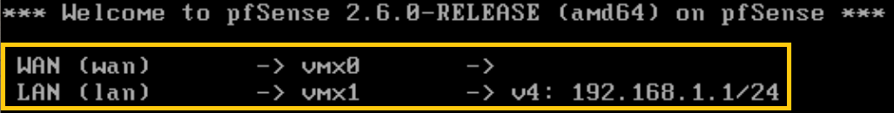

- Enter option "2" (set interface IP address) and hit enter.
  - Select interface you wish to configure :1
  - Configure IPv4 address WAN interface via DHCP: n
  - Enter the new WAN IPv4 address: X.X.X.100
  - Enter the new WAN IPv4 subnet bit count: 24
  - New upstream gateway address: X.X.X.254
  - Configure IPv6 address WAN interface via DHCP6: n
  - Enter the new WAN IPv6 address: <Press Enter for none>
  - Do you want to revert to HTTP as the webConfigurator protocol? n
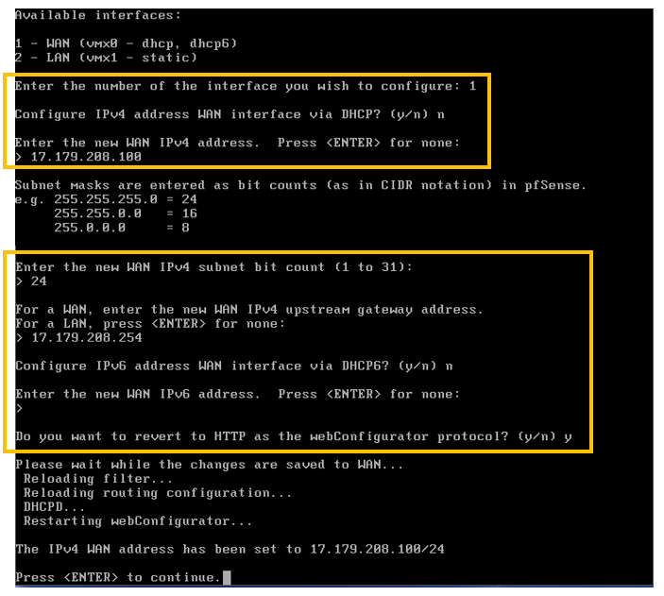
- Finally, you should be returned to the welcome screen, with the WAN interface properly configured.
- Select option "7" (ping host) to test network connectivity.
  - Enter your network's gateway IP address (X.X.X.254) and press enter.
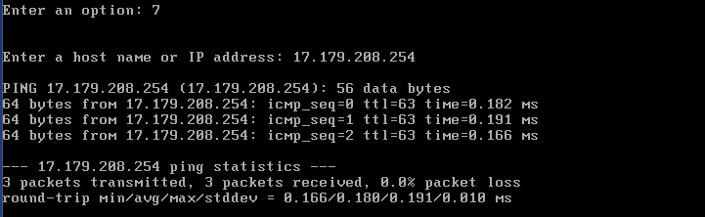
  - You should see 3 ping packets received. Take a screenshot of the successful ping.
- Now we need to set up the LAN interface to do DHCP. We will set up the MAC address reservations using the web configurator a little later in the lab. For right now we just want to get DHCP running so we can migrate the desktop over to use the web configurator.
- Enter option "2" (set interface IP address) and hit enter.
  - Select interface you wish to configure: 2
  - Enter the new LAN IPv4 address: 192.168.1.1
  - Enter the new LAN IPv4 subnet bit count: 24
  - New upstream gateway address: <Press Enter for none>
  - Enter the new LAN IPv6 address: <Press Enter for none>
  - Do you want to enable the DHCP server on LAN? y
  - Enter the start address of the IPv4 client address range: 192.168.1.190
  - Enter the end address of the IPv4 client address range: 192.168.1.198
  - Do you want to revert to HTTP as the webConfigurator protocol? n
  - Press enter to continue.

Migrating Machines
Now that we have the basics configured on our firewall, we can start moving machines onto the private network. Normally the design of a network will be determined by pre-existing systems, network access requirements, etc. This week, we will be migrating one machine onto the private network and forwarding services through our firewall as needed.

All machines behind the firewall will have their address in the 192.168.1.0/24 range. This will allow the machine to operate on the internal network. Services that are publicly available will have a public IP alias mapped to them so that requests destined for the alias will be forwarded by the firewall to the correct private IP address. A chart is provided below to help visualize this.

Machine | External IP | Internal IP
desktop1 | X.X.X.201 | 192.168.1.201

We won’t migrate to ns1. Next week you will be working with packages. As part of that lab, you will install BIND to run DNS for your network on ns1. Then, you will create a split DNS by cloning the ns1 to make ns2. Then ns1 will be your outside DNS and ns2 will be your inside DNS running behind the firewall.

Migrate the Desktop
We will be using DHCP on the pfSense firewall and MAC reservations to assign private IP addresses automatically.

- Log into your Ubuntu Desktop.
- Modify the network config settings in /etc/netplan/01-netcfg.yaml.
  - Under ens192: add the line dhcp4: yes.
  - Comment out the following lines by inserting a # before each of these lines:
addresses: [X.X.X.201/24]
routes:
- to: default
via: X.X.X.254
nameservers:
addresses: [199.100.16.100]
  - Save the file and then type sudo netplan apply.
  - Update the no_proxy config in /etc/profile for the internal IP range.
printf -v no_proxy '%s,' 192.168.1.{1..254}
- In vSphere, under Edit Settings, switch the network adapter for the desktop to your internal network (cpre230_myoussef_YourNetID).
- Reboot.
- Verify you can ping the firewall (192.168.1.1). If you are unsuccessful, it means there is a networking problem that needs to be fixed before moving on. (If so, this is a good chance to practice your troubleshooting skills!)

Pfsense Gateway Setting
- Using your desktop machine, open Firefox and connect to https://192.168.1.1 which is the web configurator interface for pfSense. This may take a while to load. If you receive a “Potential Security Risk Ahead” warning, click Advanced and Accept the Risk and Continue.
Note: If the website brings up a proxy error, go into your Firefox settings and change your proxy settings to “no proxy”. Typically this is the issue if you CAN ping your 192.168.1.1 in the terminal on your Ubuntu Desktop.
- Click on the 3 bars
- Settings
- Type in proxy in the search settings, open the proxy settings and on the unordered list, click on “no proxy”.

  - Username : password == admin : pfsense
  - Go to the dropdown menu of System and select Routing.
  - In the Gateways section, ensure that the gateway you configured (XX.XX.XX.254) is the only one present (if necessary, click the delete button for any others and save).
  - In the Default gateway section, set your gateway as the IPv4 Default gateway and save your changes.
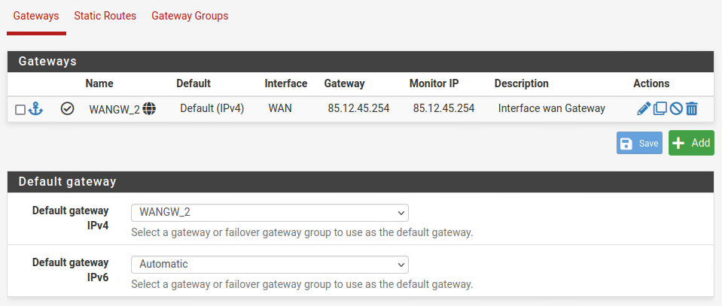
  - Verify that you can perform a sudo apt update from your desktop. If the update is unsuccessful, it means there is a networking problem that needs to be fixed before moving on. (If so, this is a good chance to practice your troubleshooting skills!)

MAC Address Reservations
Now the desktop is running DHCP client, but as it is configured now you really don’t know which IP (192.168.1.190 through 192.168.1.198) will be assigned to that machine. We want desktop1 always to be assigned to 192.168.1.201. We can have a specific IP assigned to a specific machine using MAC address reservations.
- Make sure you are logged into the web configurator as described in the previous section.
- Go to the drop-down menu of Services and select DHCP Server.
- Select the LAN tab.
- The range should be 192.168.1.190 to 192.168.1.198.
- Under Servers make sure the DNS servers are set to 199.100.16.100. You will change this to your own DNS internal server in the next lab (Lab 05). But, for now, you have to use the ISEAGE DNS since you don’t have your own configured.
- Click Save
- Scroll to the bottom of the page
- Click Add Under DHCP Static Mappings for this Interface
- You now need the MAC address for your desktop machine. Return to your vSphere client in your web browser, select your desktop machine, and click Edit Settings → Network adapter 1, and then copy the MAC address. You may need to paste this into a text editor and then retype it into pfSense.
- Return to the Ubuntu desktop machine with the pfSense web configurator open and paste or retype the MAC address.
- The fields that need to be filled out are listed below

MAC address | IP address | Hostname | Description
From vSphere client | 192.168.1.201 | desktop1 | Ubuntu desktop

- Click Save and Apply Changes.
- You will have to do the MAC reservations for each new server we add throughout the semester.

Setting Firewall Policies
Part of the setup for a firewall is to create policies to allow specific machines to be accessed from the public internet. In a residential setting (your home router), port forwarding is typically used, as only one public IP is typically available from your ISP. This means that different port requests to the same IP address can be split amongst several hosts.

Here, we have an entire range of public networks to use (XX.XX.XX.0/24), so we will be using virtual IPs and port forwarding together. This allows services to be "offered" on several addresses, which are then forwarded by the firewall to the respective servers on the internal network.

Port Forwarding Only:
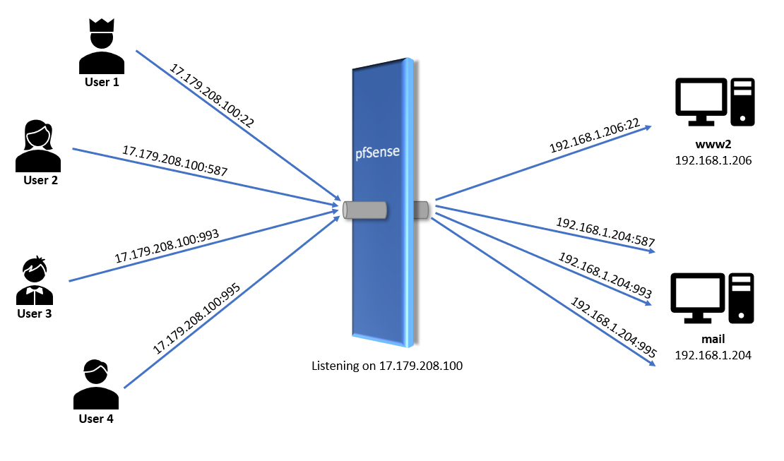

Virtual IPs with Port Forwarding:

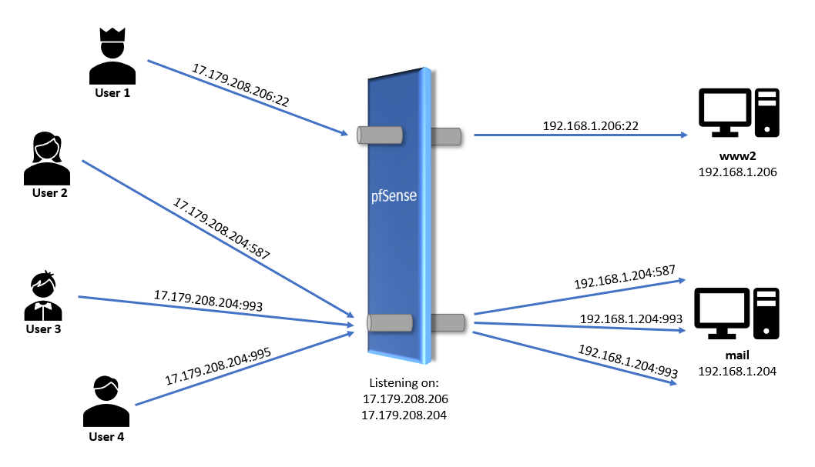

As you can see, this allows for more ports to be used (instead of one port range for one IP, we can use one port range per IP) along with letting us forward/block/filter specific port requests per host. What additional pros and cons are there to Virtual IPs with Port Forwarding vs Port Forwarding Alone? Discuss in your lab writeup.

Creating Virtual IPs and Forwarding Rules
For each host we wish to allow public access to, we will need to create its respective IP alias. There is a table below to show what virtual IP should be assigned to each computer from the past labs and for the future labs. To assign virtual IPs, we will use the pfSense web configuration interface from the comfort of our Ubuntu Desktop. To start the semester, we will be allowing public access using virtual IPs to all the machines behind the firewall. As the semester progresses, we will start to restrict the public access as we add services.

- Take a snapshot of your pfSense machine and name it “Pre-Firewall Policies”
- Log into your Ubuntu desktop.
- Open Firefox and navigate to https://192.168.1.1 .
  - Log in using the credentials:
    - Username: admin
    - Password: pfsense
- First, check to make sure the DNS Server is set. Since you don’t have your own DNS running yet, you will use the ISEAGE DNS this first week. From the top menu select “System” -> “General Setup”. In the section labeled DNS Server Settings make sure it says 199.100.16.100. If there is a different value, change it to 199.100.16.100. Click Save.
- Next you will proceed to adding virtual IPs. From the top menu select "Firewall"->"Virtual IPs". Click "Add" in the bottom-right corner of the screen.
  - Enter the required information.
    - Type: IP Alias
    - Interface: WAN
    - Address: an external address from the table below that corresponds to a machine connected to the internal network.
    - Address netmask: /24
    - Description: details about IP (host & purpose)
  - Click save and repeat steps 'a' and 'b' for all other public addresses that correspond to a machine connected to the internal network in the IP address table below. Most of these machines do not exist yet. We are giving them to you now to reduce weekly setup time. See figure E for proper setup. Ensure that addresses entered are from the network diagram NOT 192.168.1.X
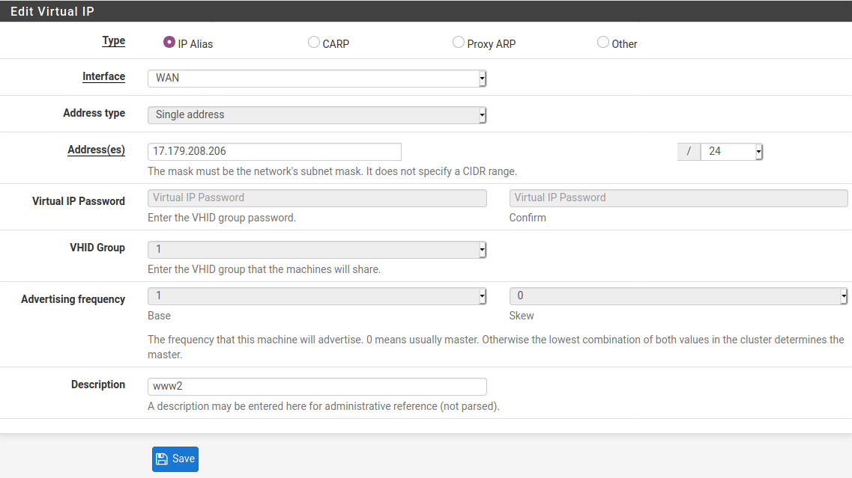

Below is the diagram for what our network will look like once finished.
Machine | External IP address  <Assigned Virtual IPs> | Internal IP address  <What is seen inside the firewall>
ns1 | <none on pfSense - stays outside the firewall> | <none on pfSense - stays outside the firewall>
ns2 | XX.XX.XX.199  (for Nagios to check internal DNS only) | 192.168.1.200
desktop1 | XX.XX.XX.201 | 192.168.1.201
www | XX.XX.XX.202 | 192.168.1.202
mail | XX.XX.XX.204 | 192.168.1.204
ldap | XX.XX.XX.205 | 192.168.1.205
www2 | XX.XX.XX.206 | 192.168.1.206
ws | XX.XX.XX.207 | 192.168.1.207
splunk | XX.XX.XX.208 | 192.168.1.208

  - Click "Apply Changes".

  - Verify you have made all the necessary changes. You should have a screen similar to the one below.
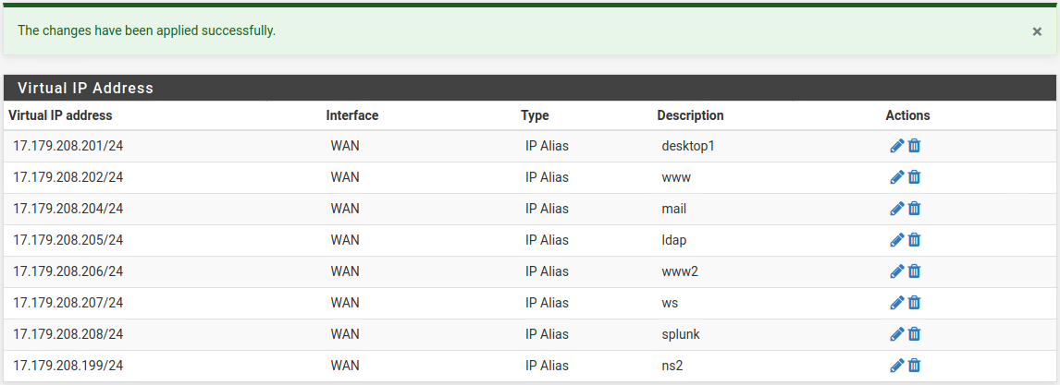
  - Change your IP by rebooting the desktop.
  - Verify your IP address is 192.168.1.201
ip addr
  - Ask a TA for help if your IP address is not correct before moving on

Disable monitoring on the WAN interface
pfSense has a feature on the WAN interface where it monitors the default gateway in the network and alerts if the WAN develops latency or goes down. The way pfSense conducts the test is to ping the default gateway twice every second (every 500 ms). That works fine in a real network. However, in the iselab testbed that generates a lot of ICMP traffic and it makes it extremely difficult for students to capture icmp packets and filter through them. So, you are going to turn off that feature.
- You should still be on your Ubuntu desktop. Log into pfSense again using Firefox if you have been timed out.
- Select System and then Routing from the drop down menu at the top of the page.

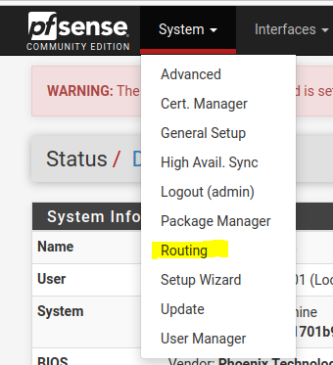
- Under Gateways select the pencil icon which is for editing.
- Put a check in Disable Gateway Monitoring and Disable Gateway Monitoring Action.
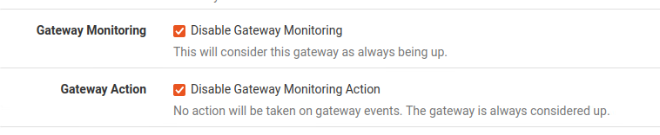
- Save and Apply Changes.

SSH on Desktop
We don’t have any services running on our desktop to add to the firewall, so let’s install ssh on the Ubuntu Desktop so we can set up a firewall rule and make sure everything is working ok. You will work more with ssh in a future lab. For now, it is just a service to test.
- On your Ubuntu desktop, install ssh.
sudo apt install ssh
- Check to see if ssh is running
systemctl status ssh
If it is inactive
systemctl start ssh (verify the status once again)
- Type ‘q’ to exit
- Now, you have to add a rule to allow the ssh traffic through your firewall. Return to Firefox and if it isn’t still open, Open the pfsense web configurator.
- Navigate to "Firewall"->"NAT" in the top navigation menu. This is where you will set up port forwarding. This week we will just allow ssh traffic through the firewall to your desktop machine. You probably would not do this in the real world. Allowing ssh any IP from the outside world is not a good security practice. You are doing this so you can test the firewall and we can use Nagios to grade your firewall installation. It is more likely you would only allow ssh from an internal IP range or a specific IP address. Don’t try that now. It will only mess up your lab.
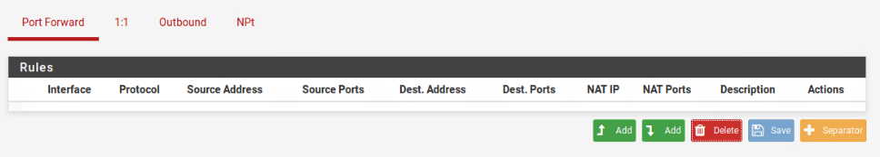
  - Click either of the Add buttons. The left one adds rules to the top of the list. The right one adds rules to the bottom of the list.
  - Enter needed information to forward ssh requests to the internal server.
    - Interface: WAN
    - Protocol: TCP
    - Source: Leave Advance Settings hidden for now. It defaults to any/any. Again, this is not a great idea in the real world.
    - Destination: the desired Virtual IP from dropdown which is X.X.X.201 for the desktop
    - Destination port range: SSH
    - Redirect target IP: internal IP (192.168.1.201) from table above
    - Redirect target port: SSH
    - Description: desktop - Nagios ssh check

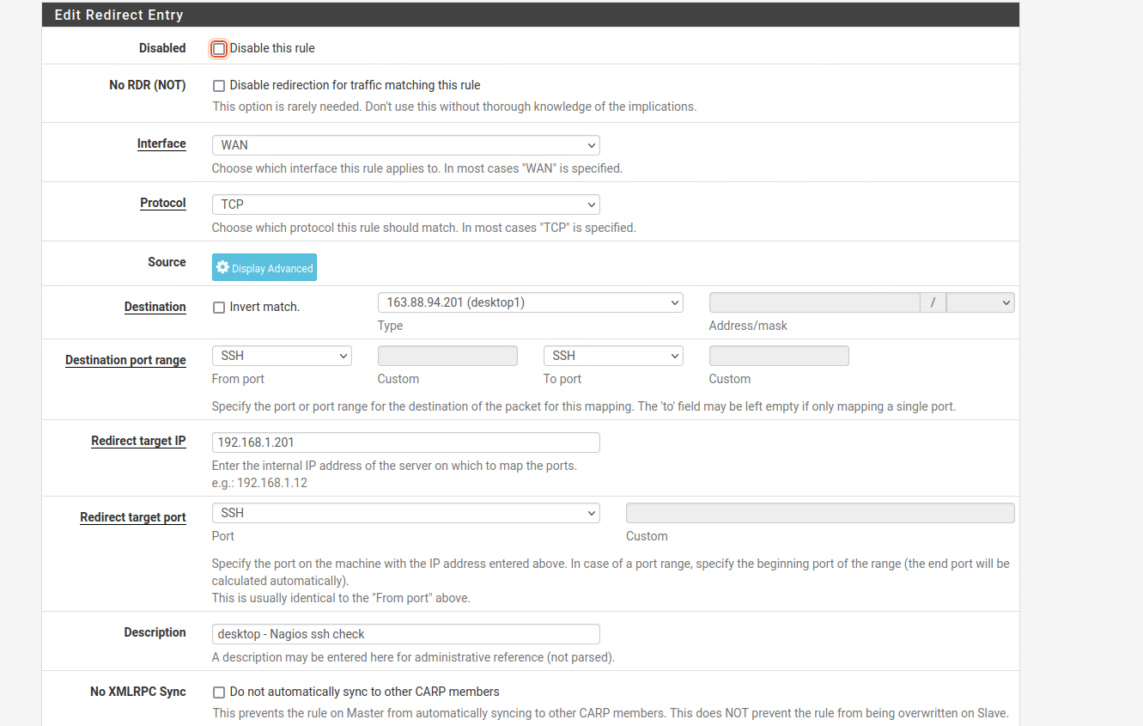

  - Click "Save.”
  - Click “Apply Changes."
- You will add separators to make it easier to find rules about specific servers. Click on the orange Separator button and type Desktop - Nagios check.
- Click the darker blue Save button. This just saves the name. Then, click the light blue Save button.
- Move your Port Forward rule under the separator. It should look like the image below:

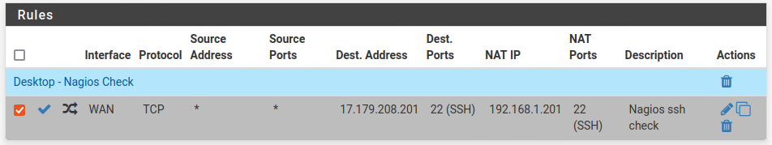
- Now log into your ns1 machine and let’s see if we can connect to the new ssh server running on your desktop through the port we just opened in the firewall. (Your username on the ubuntu desktop should be your netid)
ssh username@X.X.X.201
  - If the above command doesn’t work try rebooting pfsense.
- Run the command listed below. You should see output similar to the following picture.
uname -a
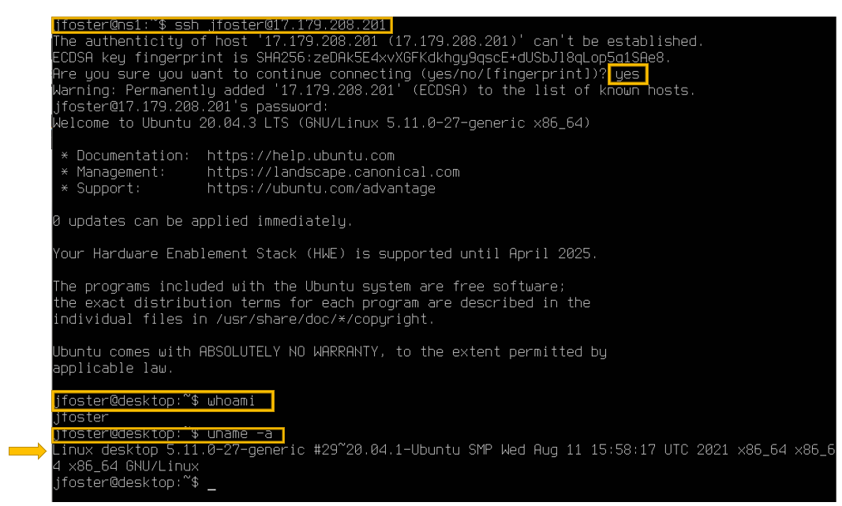
- Take a screenshot. Verify you see output related to “Linux desktop 5.11...” Submit your screenshot as #3 in the lab template under “Screenshot of successful ssh connection from your ns1 to your desktop”

- Return to your desktop and check Nagios to make sure it is correctly reporting ssh is running on your desktop. We will explain more about Nagios next week in Lab 05. For now, just open Firefox and go to http://monitor.homework.230.com/nagios/ and log in with username/password monitor/cpre230. Once you’re logged in you can go to the Host Groups > grid (from the left panel).
  - If you have trouble reaching Nagios, check the Troubleshooting section of the Nagios Guide first.
  - If a connection error pops up, go into Firefox settings and disable DNS over HTTPs. This option should not be enabled. (Search DNS in firefox settings)
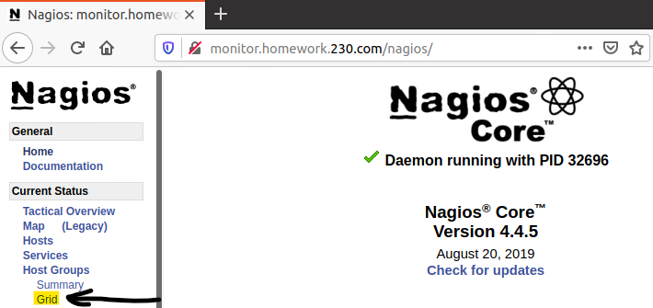

- That will show you a list of all the host groups, which are the servers grouped by student number. If you don’t know your student number, it is in the Network Information document along with your IP information. You can click on your student number to see a more detailed view of your servers. Note: the groups are not in numeric order (i.e 10 comes immediately after 1), so you may have to do a Ctrl+F to find your group.
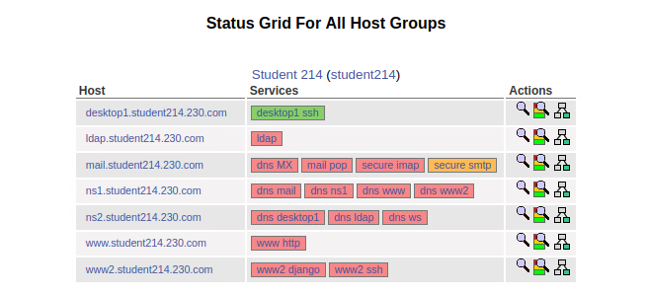
- Don’t worry that most of your services will be showing red (critical) currently. They are services that you will set up in later labs. Currently, the only services you need to look at are for your desktop1 machine (desktop1.studentXX.230.com). This may take a few minutes to turn green based upon the timing of the Nagios checks.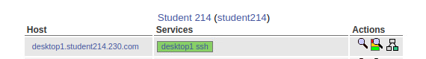

- In your lab report submit screenshots of Virtual IP config page, NAT forwarding page and Nagios with ssh to your desktop displaying green.

Network Diagram
- You will begin work on a network diagram of studentXX.230.com. The final diagram will look something like the one below. This week you will just have the two machines (desktop1 and ns1), as well as your firewall.
- Network resources should have all available ports/services notated.
  - Network resources should have an IP address.
  - Any required port forwarding should be notated on the Firewall/NAT.
  - Submit your beginning diagram in lab writeup.

